美國賓州大學Akhlesh Lakhtakia教授訪台之三場演講訊息(免費報名參加)
主講人：Akhlesh Lakhtakia教授
時間與地點：
日期/ 時間 | 地點 | 場次 | 講題
11 月26 日(二)  10:00 ~ 11:30AM | 國立台北科技大學光華館4F階梯教室 | Part 1 | Surface Multiplasmonics and Dyakonov-Tamm Waves
11 月29 日(五)  9:30 ~ 11:00AM | 中央研究院  跨領域科技研究大樓 | Part 2 | Sculptured Thin Films
11 月29 日(五)  2:00 ~3:30 PM | 國立中央大學  國鼎光電大樓 | Part 3 | Biomimicry for Harvesting Solar Energy

主講人現職：
美國賓州大學Department of Engineering Science and Mechanics教授
美國科學促進會(AAAS) Fellow
國際光學工程學會(SPIE) Fellow
美國光學學會(OSA) Fellow
英國物理學會(Institute of Physics, UK) Fellow
國際期刊Journal of Nanophotonics 總編輯(Editor–in–Chief)
國立台北科技大學國際講座教授
主講人獲獎(選列)：
Nano 50 (Technology) Award (2005)
Nano 50 (Technology) Award (2006)
SPIE Technical Achievement Award (2010)
聯絡人：任貽均教授Email: jyjun@ntut.edu.tw
Professor Akhlesh Lakhtakia

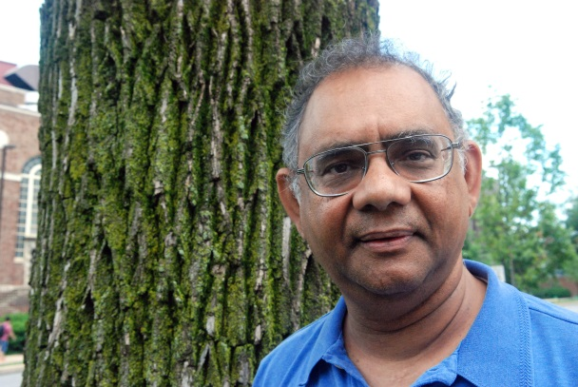

Short Biography:
Akhlesh Lakhtakia received degrees from the Banaras Hindu University (B.Tech. & D.Sc.) and the University of Utah (M.S. & Ph.D.), in electronics engineering and electrical engineering, respectively. He is the Charles Godfrey Binder (Endowed) Professor of Engineering Science and Mechanics at the Pennsylvania State University. He is a Fellow of SPIE, Optical Society of America, American Association for the Advancement of Sciences, American Physical Society, and Institute of Physics (UK). He is founding editor-in-chief of Journal of Nanophotonics published by SPIE. His current research interests include nanotechnology, plasmonics, engineered biomimicry, complex materials, metamaterials, and sculptured thin films.

報名方式：免費報名參加。
※欲參加者請email 告知鄭祺耀先生e59302189@yahoo.com.tw。
現場報名將視座位狀況安排入座。

